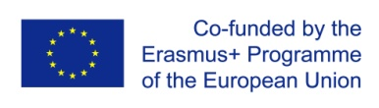 | Development of master curricula for natural disasters risk management in Western Balkan countries | 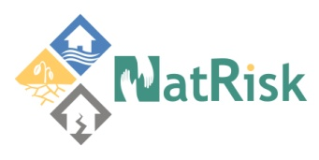

Agenda – Monitoring visit to
NatRisk project

Project title: Development of master curricula for natural disasters risk management in Western Balkan countries
Acronym: NatRisk
Project number:
573806-EPP-1-2016-1-RS-EPPKA2-CBHE-JP

Date |  |  | 26 June 2018
City |  |  | Kosovska Mitrovica
Meeting venue |  |  | Faculty of Technical Sciences, Univeristy of Priština in Kosovska Mitrovica
Address |  |  | Knjaza Miloša 7, 38220 Kosovska Mitrovica, Kosovo*
Organizers |  |  | UPKM and TCASU
 |  |  |  | Development of master curricula for natural disasters risk management in Western Balkan countries
Tuesday, 26th June 2018
Faculty of Technical Sciences, Univeristy of Priština in Kosovska Mitrovica, Knjaza Miloša 7, 38220 Kosovska Mitrovica, Kosovo*
09:45-10:00 | Participant registration
1st Session
10:00-10:15 | Opening of the meeting and introductory speeches |  |  |  |  | Nebojša Arsić, UPKM  Goran Lazić, NEO
10:15-10:30 | Presentation of UPKM, Implementation of Activities |  |  |  |  | Nebojša Arsić, UPKM
10:30-10:45 | Presentation of UPKM Curriculum development projects, Impact and Relevance of activities in relation to project objectives |  |  |  |  | Jelena Djokić, UPKM
10:45-11:00 | Presentation of TCASU planned and realised activities |  |  |  |  | Jelena Rajović, TCASU
11:00-11:20 | Coffee break
2nd Session
11:20-11:50 | Project documentation monitoring |  |  |  |  | Goran Lazić, NEO
11:50-12:20 | Finances of the project |  |  |  |  | Goran Lazić, NEO
12:20:12:50 | Questions and answers, discussion |  |  |  |  | Goran Lazić, NEO
12:50-13:00 | Conclusions and recommendations

